DOWNTOWN MANHATTAN:
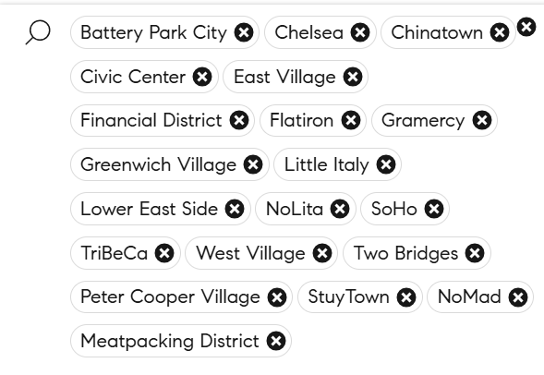
MIDTOWN MANHATTAN:
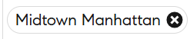

UPTOWN MANHATTAN:
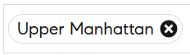
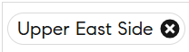
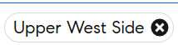
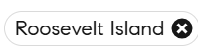
All Downtown
Battery Park City
Chelsea
West Chelsea
Chinatown
Civic Center
East Village
Financial District
Fulton/Seaport
Flatiron
NoMad
Gramercy Park
Greenwich Village
Noho
Little Italy
Lower East Side
Two Bridges
Nolita
Soho
Hudson Square
Stuyvesant Town/PCV
Tribeca
West Village
All Midtown
Central Park South
Midtown
Midtown East
Kips Bay
Murray Hill
Sutton Place
Turtle Bay
Beekman
Midtown South
Midtown West
Hell's Kitchen
Hudson Yards
Roosevelt Island
All Upper East Side
Upper East Side
Carnegie Hill
Lenox Hill
Upper Carnegie Hill
Yorkville
All Upper Manhattan
Central Harlem
South Harlem
East Harlem
Hamilton Heights
Inwood
Marble Hill
Morningside Heights
Washington Heights
Fort George
Hudson Heights
West Harlem
Manhattanville
All Upper West Side
Upper West Side
Lincoln Square
Manhattan Valley

NEIGHBORHOODS = [
# Downtown
"Battery Park City", "Chelsea", "Chinatown", "Civic Center", "East Village", "Financial District", "Flatiron", "Gramercy", "Greenwich Village", "Little Italy", "Lower East Side", "NoLita", “Peter Cooper Village”, "SoHo", "TriBeCa", "West Village", "Two Bridges",
# Midtown
Central Park South, Midtown, Midtown East, Midtown South, Midtown West, Roosevelt Island
# All Upper East Side
Upper East Side
# Uptown
Central Harlem, East Harlem, Hamilton Heights, Inwood, Marble Hill, Morningside Heights, Washington Heights, West Harlem
# All Upper West Side
Upper West Side
]

REDFIN:

https://www.redfin.com/neighborhood/207016/NY/Manhattan/Central-Harlem/rentals
https://www.redfin.com/neighborhood/207305/NY/Manhattan/East-Harlem/rentals
https://www.redfin.com/neighborhood/498555/NY/Manhattan/Hamilton-Heights/rentals
https://www.redfin.com/neighborhood/207823/NY/Manhattan/Inwood/rentals
https://www.redfin.com/neighborhood/208548/NY/Manhattan/Marble-Hill/rentals
https://www.redfin.com/neighborhood/498556/NY/Manhattan/Morningside-Heights/rentals
https://www.redfin.com/neighborhood/207082/NY/Manhattan/Washington-Heights/rentals
https://www.redfin.com/neighborhood/498550/NY/Manhattan/West-Harlem/rentals

https://www.redfin.com/neighborhood/498546/NY/Manhattan/Upper-West-Side/rentals
https://www.redfin.com/neighborhood/498409/NY/Manhattan/Upper-East-Side/rentals

https://www.redfin.com/neighborhood/498343/NY/Manhattan/Downtown-Manhattan/rentals

DOUGLAS ELLIMAN:

https://www.elliman.com/rentals/central-harlem-new-york-ny
https://www.elliman.com/rentals/east-harlem-new-york-ny
https://www.elliman.com/rentals/hamilton-heights-new-york-ny
https://www.elliman.com/rentals/inwood-new-york-ny

